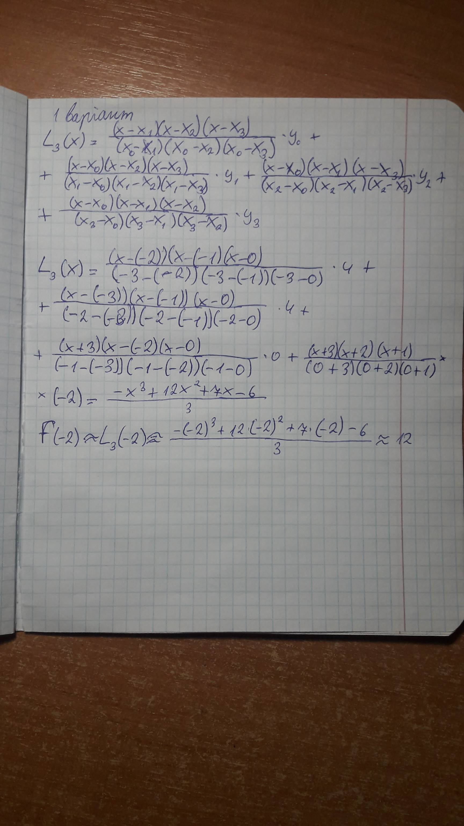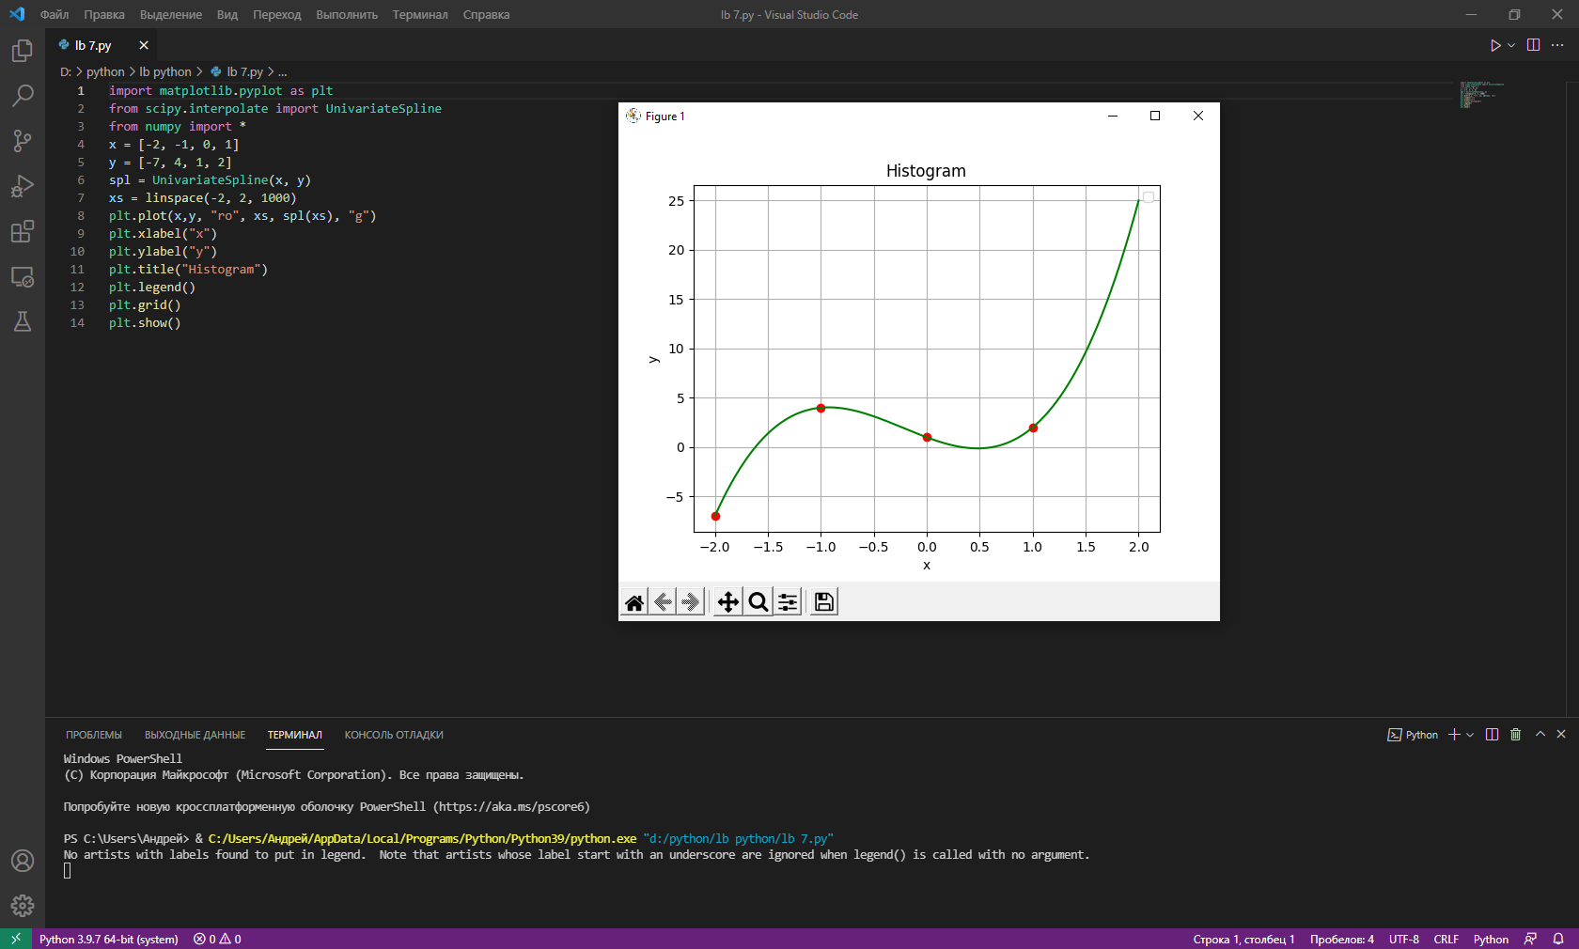

import matplotlib.pyplot as plt

from scipy.interpolate import UnivariateSpline

from numpy import \*

x = [-2, -1, 0, 1]

y = [-7, 4, 1, 2]

spl = UnivariateSpline(x, y)

xs = linspace(-2, 2, 1000)

plt.plot(x,y, "ro", xs, spl(xs), "g")

plt.xlabel("x")

plt.ylabel("y")

plt.title("Histogram")

plt.legend()

plt.grid()

plt.show()